**General Instructions**: ***Only for Windows, and instructions were tested on Windows 10***:

1. Get the code:

Go to: <https://github.com/USEPA/Predicting-Ecosystem-Response-and-Recovery-to-Nutrients>

For now, just get the zip file. Using github properly will be in another tutorial**. Click the green **Clone or download** button and **Download ZIP**.

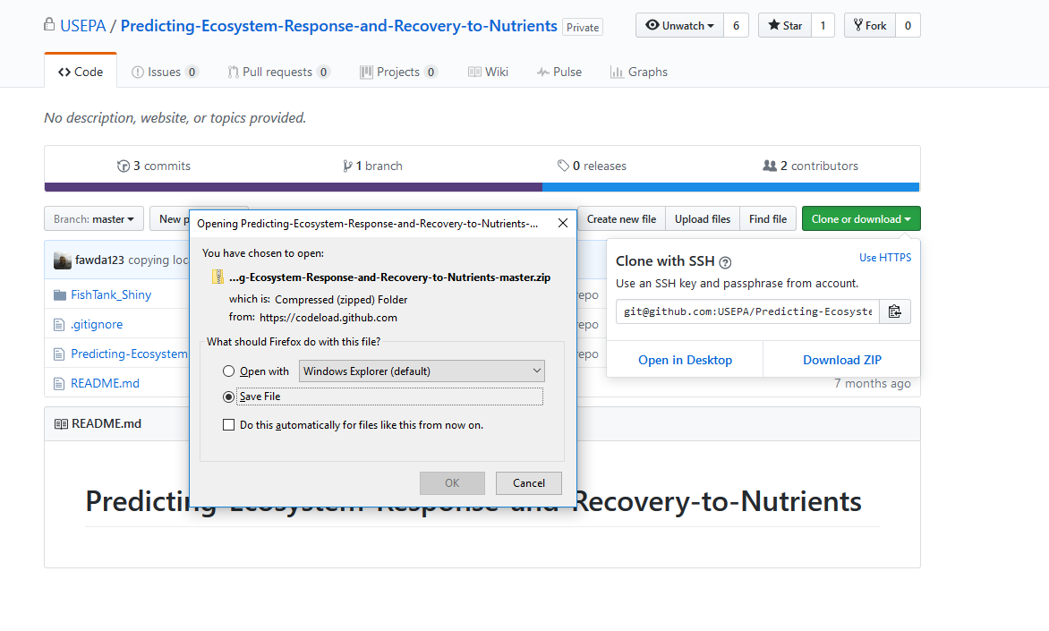Save to your computer. Usually it will go to your Downloads folder. Move it somewhere else (e.g. Documents), right click on the zipped file, and **Extract All**.

1. Have R Studio installed, then:

Install necessary packages, click “Packages, Install”:

-shiny

-shinyjs

-ggplot2

-dygraphs

-dplyr

-tidyr

-xts

-ncdf4

-htmltools

Close R Studio.

1. Go to where you unzipped the directory from github, and cd into the directory Predicting-Ecosystem-Response-and-Recovery-to-Nutrients-master\Predicting-Ecosystem-Response-and-Recovery-to-Nutrients-master. In that directory, double click Predicting-Ecosystem-Response-and-Recovery-to-Nutrients.Rproj.  This will launch R Studio and you should be in that directory. Verify by typing “getwd()” in the Console.
2. Under the **Files** tab, go to the “FishTank_Shiny” subdirectory. 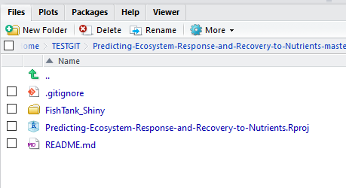

* In FishTank_Shiny, click on the file ui.R within R Studio in the files tab, and the file ui.R will appear in the left top panel. Click on RunApp (green arrow on the right of ui.R). This tutorial was tested with “Run in Window” selected.

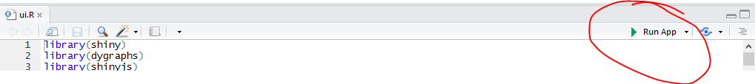

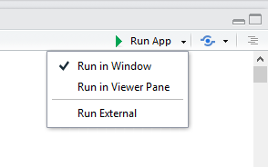

-          Clicking on **Run App** should open a window with the FishTank application.  If you have an error and need to install something else, first click on the red stop sign  to stop RShiny, then install the package, then click Run App again.

-          FishTank for R Shiny will open in a browser and the first tab will be **Select parameters**.  Click on the **Model output** tab.  Now click on the **FishTank GEM** logo button in the top left hand corner. 

“FishTank is running…" appears in the bottom right corner



and the **Model output** tab displays plots for default O2 and PO4.

**Troubleshooting:**

If you try to run R Shiny and nothing seems to happen, check to see if you can run the executable by itself by clicking on FishTank.exe in the FishTank_Shiny directory. You may get a warning because Windows does not recognize the executable. Click “More info”, and “Run Anyway”. You should only have to do this once (or once for each time you download a new executable). We are working to fix this problem.

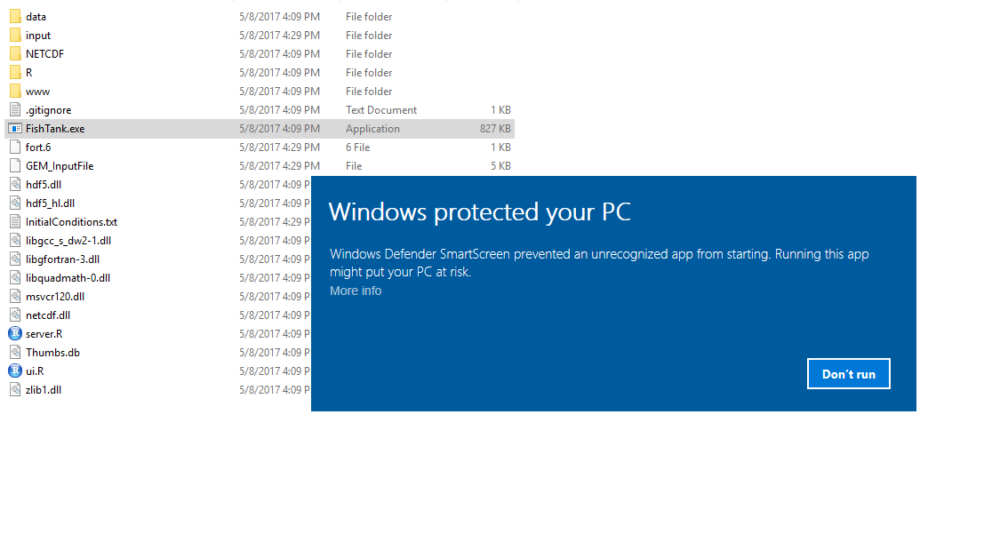

**Also note:**

* The code generates a GEM_InputFile from .RData files and from user input. If you add a GEM_InputFile, or an InitialConditions.txt file, it will be overwritten. If you are, or want to become, an advanced user and would like to use your own inputs, email [lowe.lisa@epa.gov](mailto:lowe.lisa@epa.gov) for some instructions and R Scripts for running outside of R Shiny.
* The file ‘fort.6’ is generated in the FishTank_Shiny directory on program execution. This will show error messages that do not get sent to R Shiny.
* The files GEM_InputFile, InitialConditions.txt, and NETCDF/output.000000.nc are generated by the executable. Check the date stamps on these to see if the executable ran.

**Foreward:**

Thank you for beta testing the FishTank tutorial. It is a work in progress and we need your feedback on all issues including the instructions, the interface, and the ecology. You may email [lowe.lisa@epa.gov](mailto:lowe.lisa@epa.gov) with suggestions, comments, feature requests, and bug reports if you do not have access to the github repository. For those with github access, please post issues, comments and results on the issues and Wiki of the github.

**Getting the code using GitHub:

https://help.github.com/desktop/guides/getting-started/installing-github-desktop/

First sample run with output:

1. Start FishTank as per the general instructions
2. Run FishTank by clicking the FishTankGEM button. A gray button will appear in the right bottom corner that says “FishTank is running…” The **Model output** tab default shows O2 and PO4:

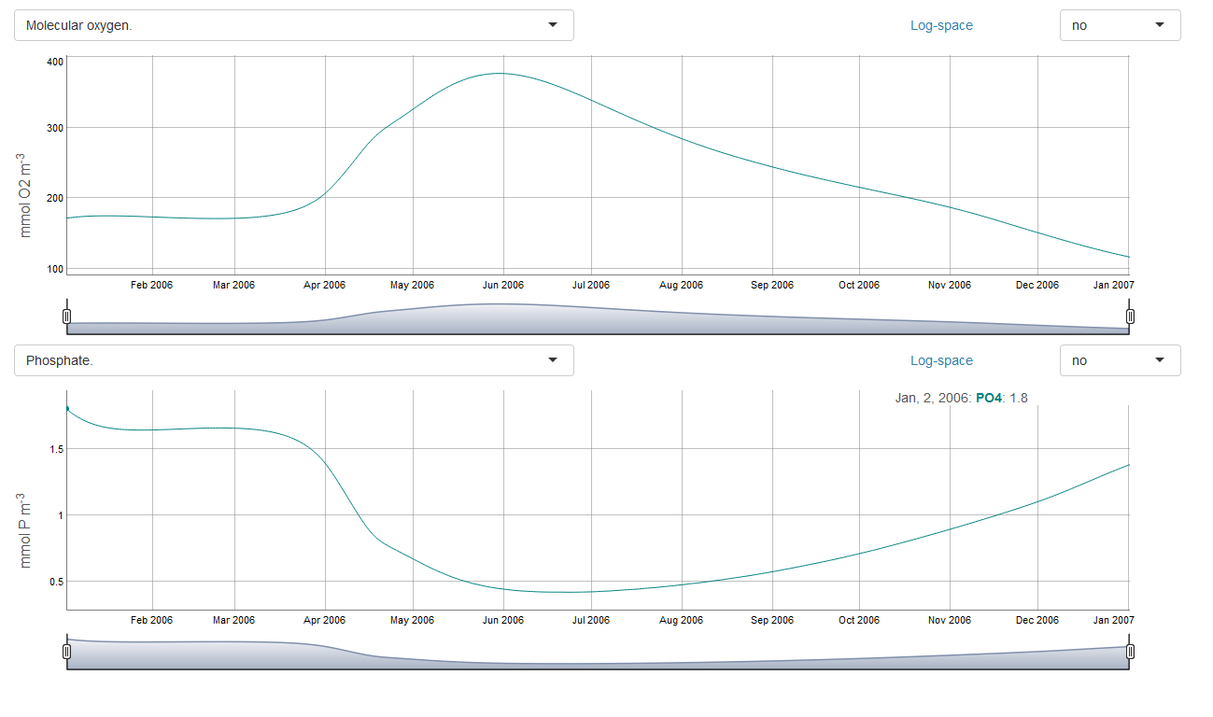

1. Change the plots to show Phytoplankton group 1 number density on the top, and Zooplankton group 1 number density on the bottom.

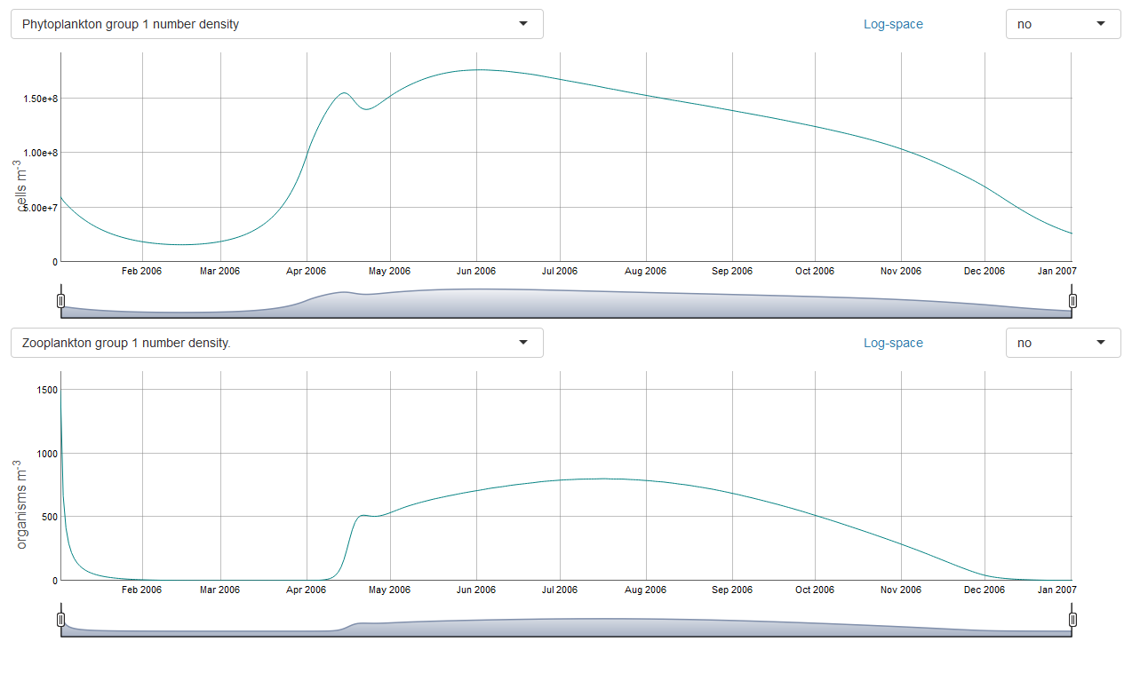

1. Click the **Select initial conditions** tab. Set all Phytoplankton abundance A1:A6 and Zooplankton group 1 and group 2 to zero and run again. Look at the results in **Model output**. The code automatically sets a minimum of **1** for these variables to avoid numerical problems. When looking at mass imbalance problems, keep in mind that the code will not allow negative values and it sets them to zero (or 1 for plankton), which can add mass. This usually doesn’t create problems under normal circumstances (physically realistic parameters and reasonable time step values).

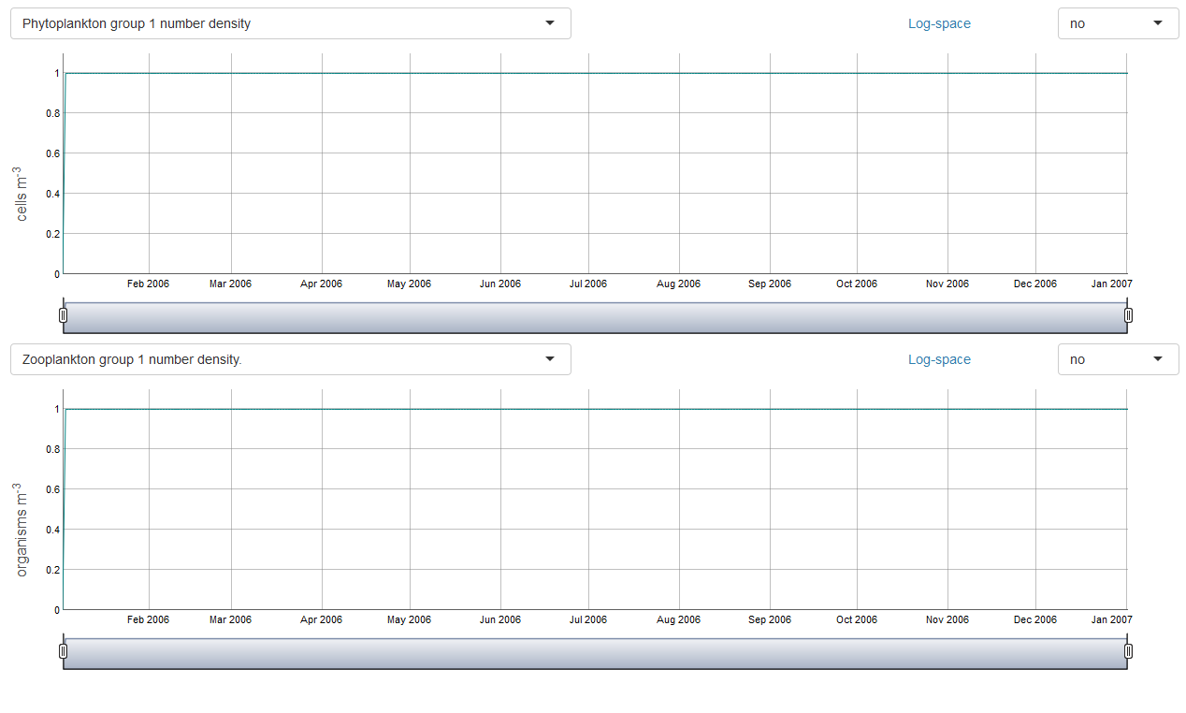

1. The **Select parameters** tab shows 6 phytoplankton and 2 zooplankton species. We can change this to run only one phytoplankton group and one zooplankton group. Click the **Reset all** button under the **FishTank GEM** button to reset the initial conditions, then toggle the switch **One Phytoplankton, One zooplankton** under **Simulation specifics and switches** to 1. Rerun and examine the results.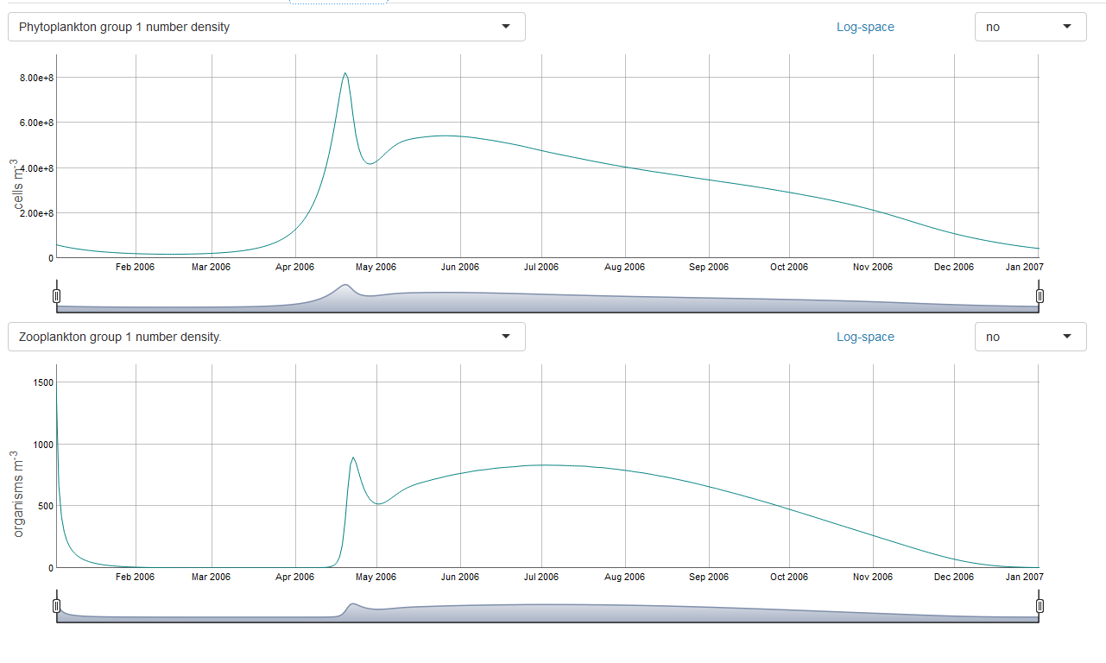
2. Go back to the **Select Parameters** tab. We will go over some of the phytoplankton parameters. Note that while there are 6 places for each phytoplankton parameter, we have selected **One phytoplankton** and FishTank will ignore the last 5 parameters. FishTank will only look at the first value for **Phytoplankton**, the first value for **Zooplankton**, and the first and seventh value in the **Temperature** functions (phyto+zoo). To look at the behavior of the phytoplankton without the effects of zooplankton grazing, we can turn off the zooplankton’s ability to eat phytoplankton by making *Athresh* a very high number. Zooplankton can only graze if the number of phytoplankton is greater than *Athresh*. Set *Athresh* to 1e10. (Only do this for testing, it isn’t physically realistic.) Run, then look at **Model output**. Turn Log-space on for both plots.

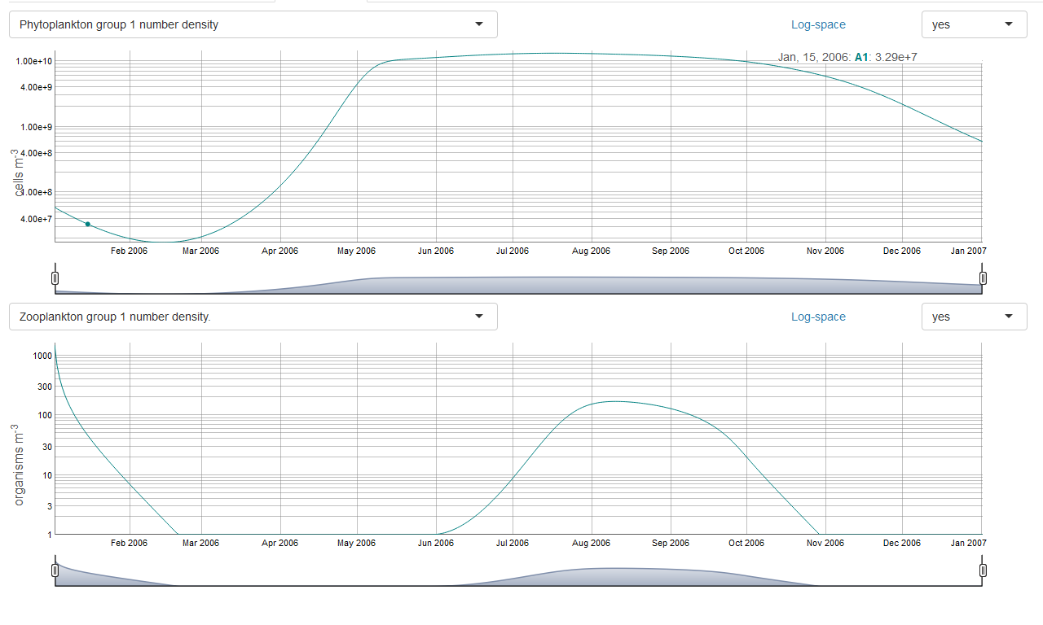

Setting *Athresh* to 1e10 worked until phytoplankton grew higher than 1e10 cells/m3. Set *Athresh* back to 7e7, but change the zooplankton **Initial conditions** to zero. Again, since we don’t let zooplankton go to identically zero, they ramp up when phytoplankton is greater than *Athresh*:

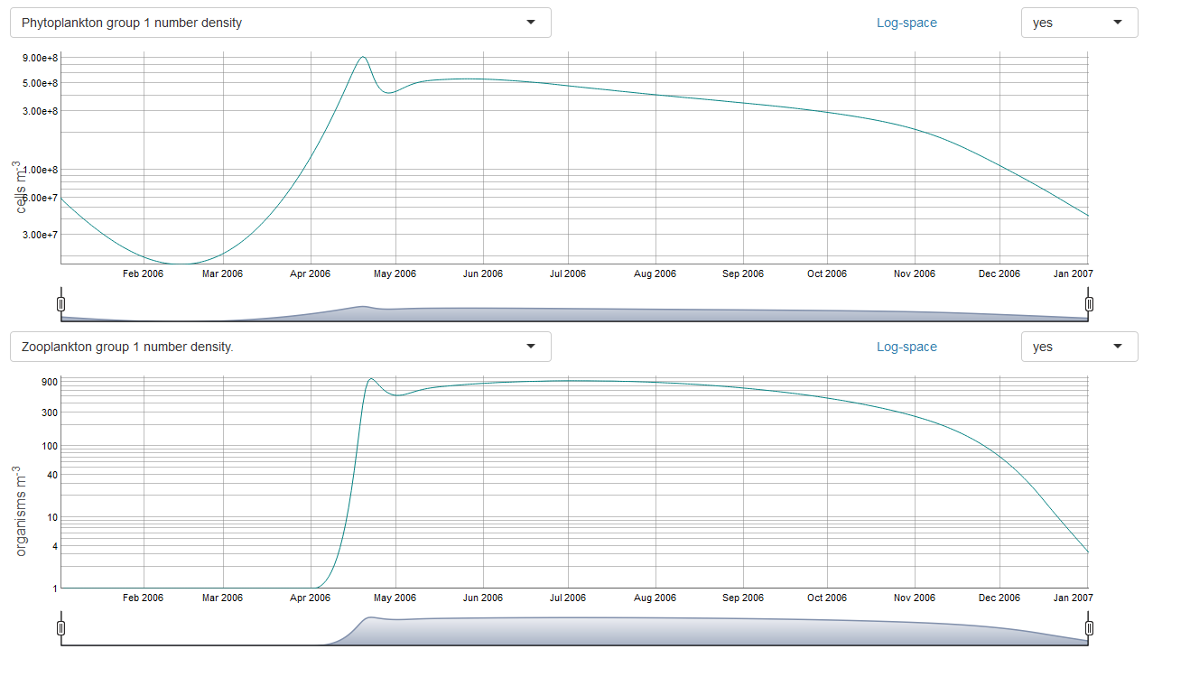

We will use another technique to get rid of those pesky critters…’edible vector’ is the percent of the phytoplankton that is ‘edible’ to the zooplankton. If we set it to zero, the zooplankton cannot grow from eating phytoplankton.

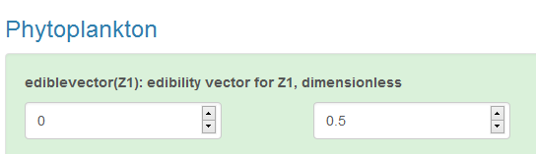

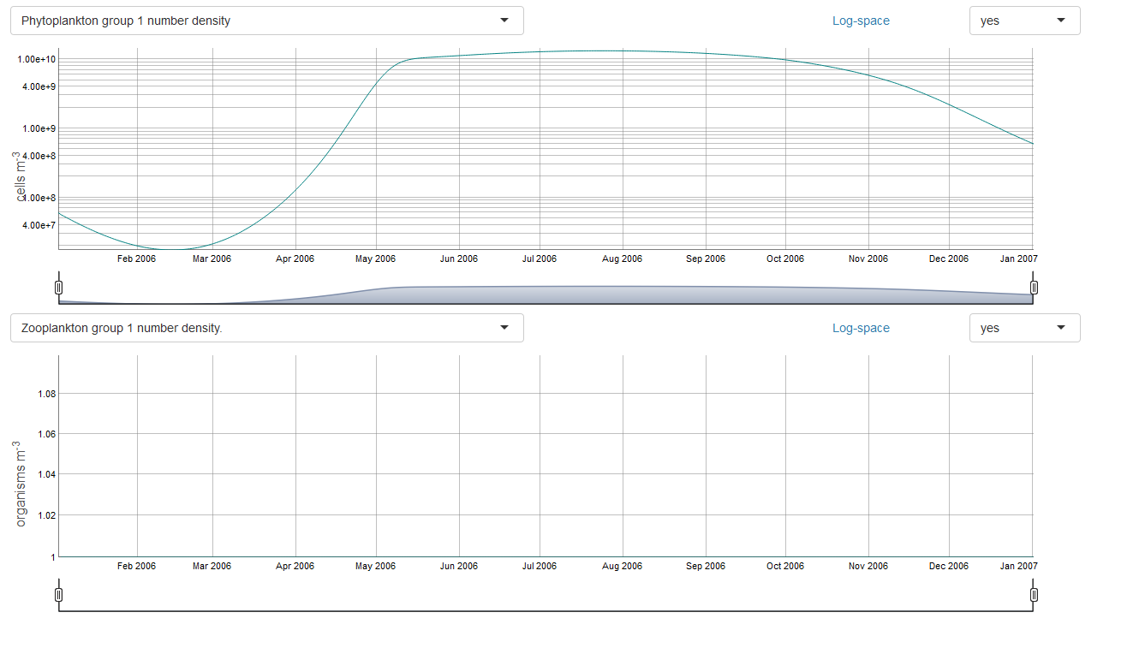

1. Now let’s change some other phytoplankton parameters. Select **Molecular oxygen** in the second plot so we can look at something more interesting than no zooplankton. It is ridiculously high from too much phytoplankton and no surface oxygen flux model- we can worry about that later. The parameter *umax* is the maximum growth rate for phytoplankton. Let’s cut it in half, set *umax*=.56 on the **Select parameters** tab under **Phytoplankton**, click run, and look at **Model output**. Note that we did stunt the growth a bit, the growth is not linear with *umax* (did not decrease by half).

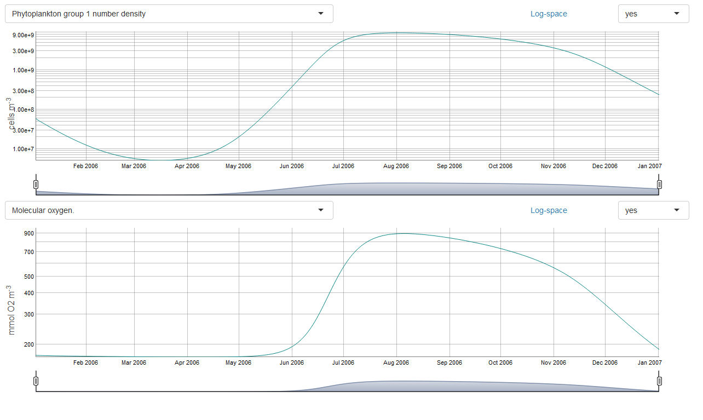

1. The next parameter is *alpha*, a factor that multiplies the irradiance at the cell (in an exponentially decaying function). Add another zero before the three (multiply by .1). This will make the phytoplankton almost always light limited, not nutrient limited, and inhibits growth. In the plot below, phytoplankton and *uE*, the light-dependent growth rate for phytoplankton, are shown.

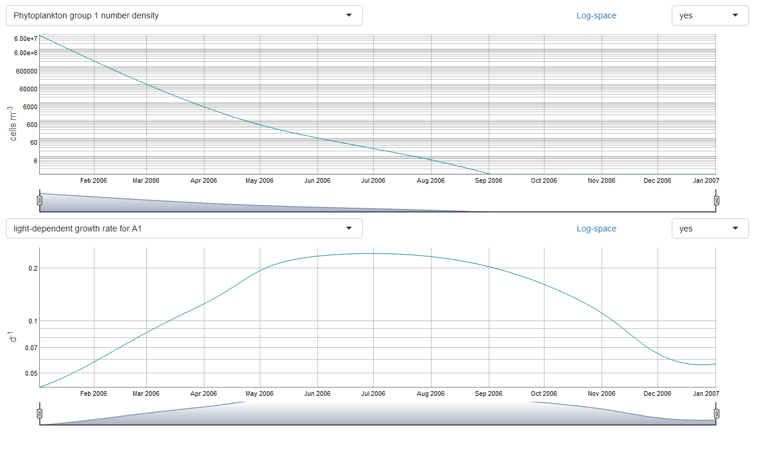J. Lehrter set this parameter according to a paper [add citation], and I don’t recommend changing it unless you know why it might be changed…so let’s change it back now (get rid of a zero in *alpha*)!

1. Let’s skip down to mortality. The mortality (parameter *mA*) is the percent of phytoplankton that die off in a timestep. This is currently 11%. Double this (mA=.22) and look at the results. So- maybe that was overkill. Try 0.15:

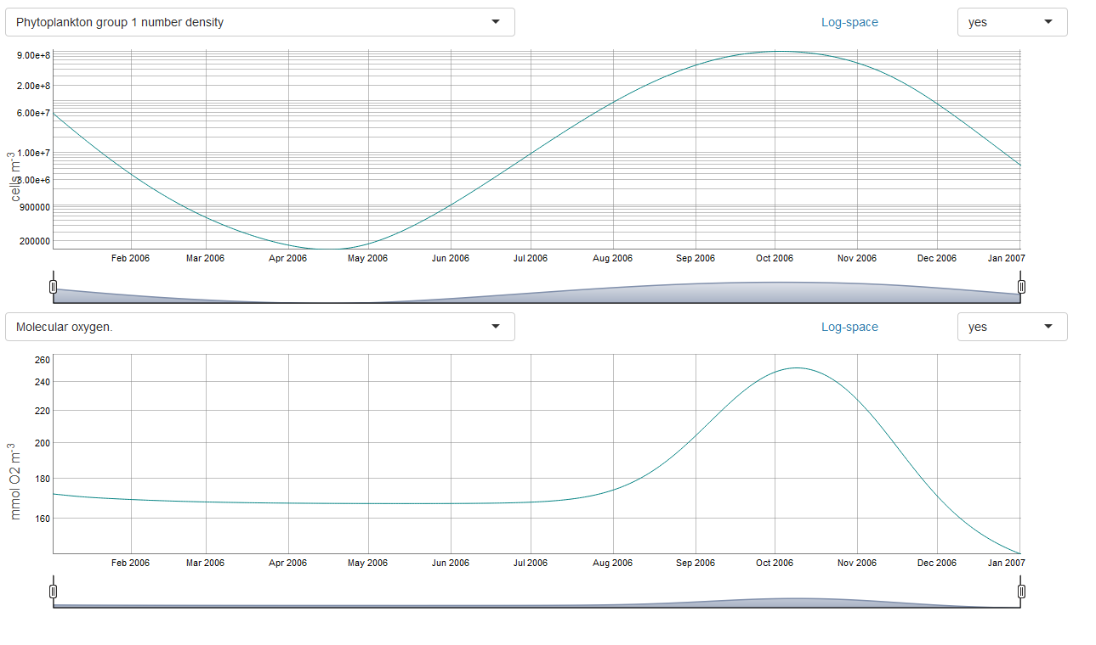

1. Phytoplankton are governed by adding growth, less respiration, less mortality (and usually less grazing but we turned that off). ‘respg’ is dependent on the growth rate, and ‘respb’ is directly related to the phytoplankton number. Double each one (one at a time) and look at the results. Now everything is pretty low. Put the mortality back to the original (mA=.11) to counteract what you added to respiration. Here is the plot after those three changes:

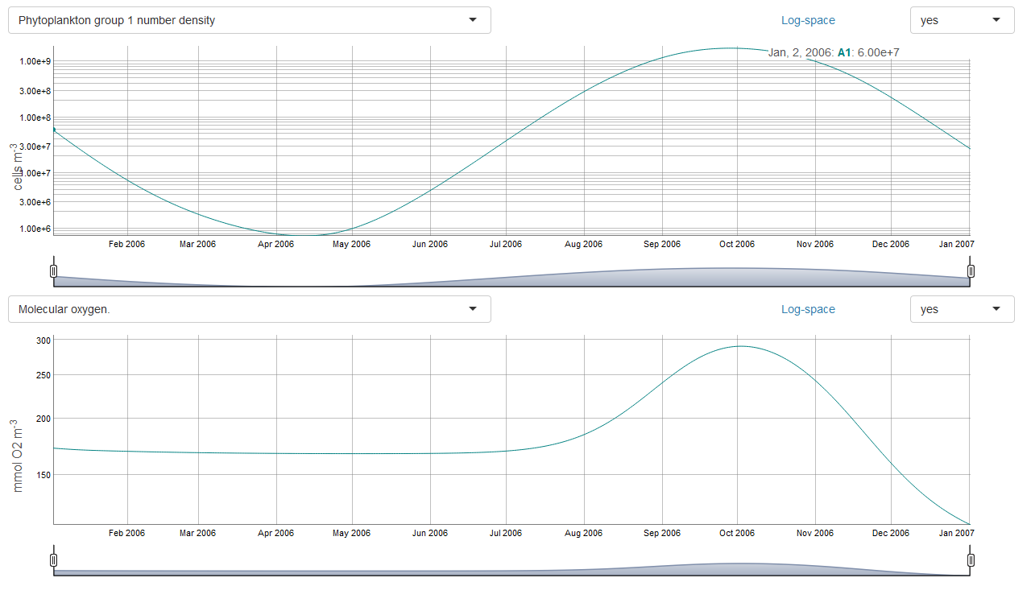

1. One last test example for phytoplankton. Hit ‘Reset all’*, then toggle on One Phytoplankton, One zooplankton, and Run. In **Model output**, choose Phytoplankton in the first plot and Phosphate in the second plot. Turn off log-space. Now set the initial conditions of PO4 to 1e-8. I want to test a theory that the phytoplankton should die off because they don’t have enough PO4. The phytoplankton do die off, but the test is confusing because PO4 increases. Why does PO4 increase?

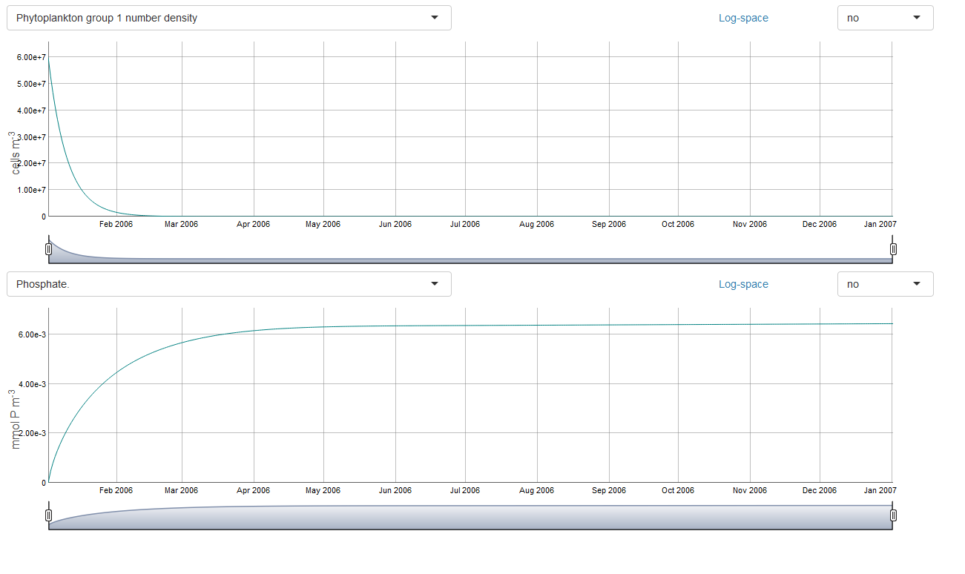

When phytoplankton die, they becomes organic matter, so look at the output **Particulate organic matter derived from dead algae** and **Dissolved organic matter derived from dead algae**. It increases until phytoplankton go to zero. It has a dip because it is both increasing and being decomposed at the same time. When it decomposes, it puts PO4 back into the water column through remineralization, and that is why PO4 increases until the OM has completely decomposed. Mass balance tests will show that the amount of PO4 contained in the initial phytoplankton will be the amount of OM released to the water column. (OM derived from phytoplankton is partitioned into ‘particulate’ and ‘dissolved’ as a function of the Nutrient Quotients (Qn, Qp, Qc) [see Lehrter, et. Al. in progress].)

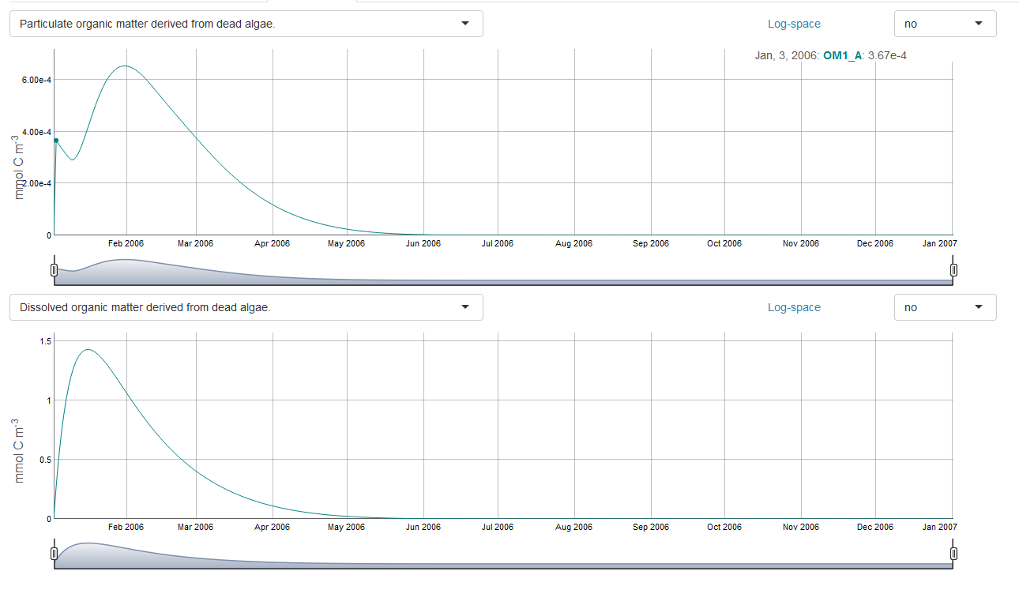

1. One last test example for part one of the tutorial. Reset all and toggle on **One phytoplankton, One zooplankton**, and we will examine how organic matter breaks down, regardless of plankton. If you do this by setting the initial A and Z to zero, you will find a bug! Go ahead and set A to zero in the initial conditions, and look at plots of Nitrate, Ammonia, and Phosphate. I already warned you that it might mess up mass balance, but this is pretty bad. Don’t do that again (and I’ll look into it later).

With the initial conditions reset to the original values, turn off phytoplankton and zooplankton activity by setting edible vector=0, phytoplankton growth and decay parameters to zero (*umax*, *respg*, *respb*, *mA*) and zooplankton growth and decay parameters to zero (*Zrespg*, *Zrespb*, *Zm*), and confirm you that have a steady state for plankton.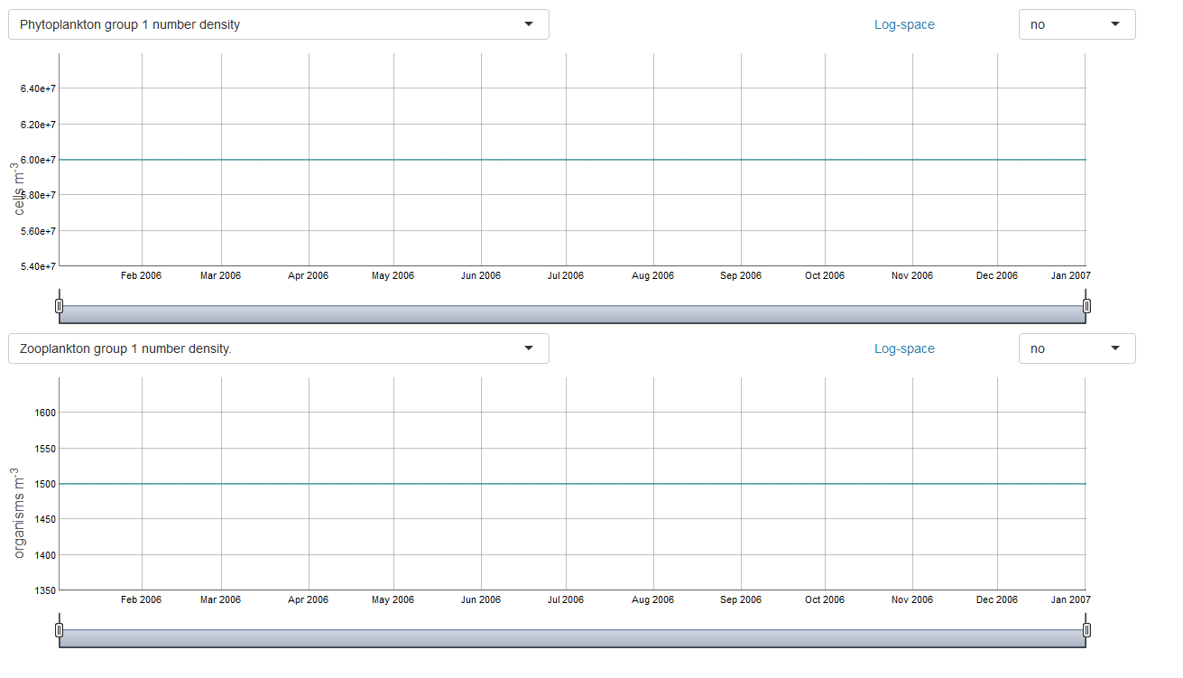

Add a big chunk of particulate organic matter by setting OM1_bc=50 in the initial conditions.

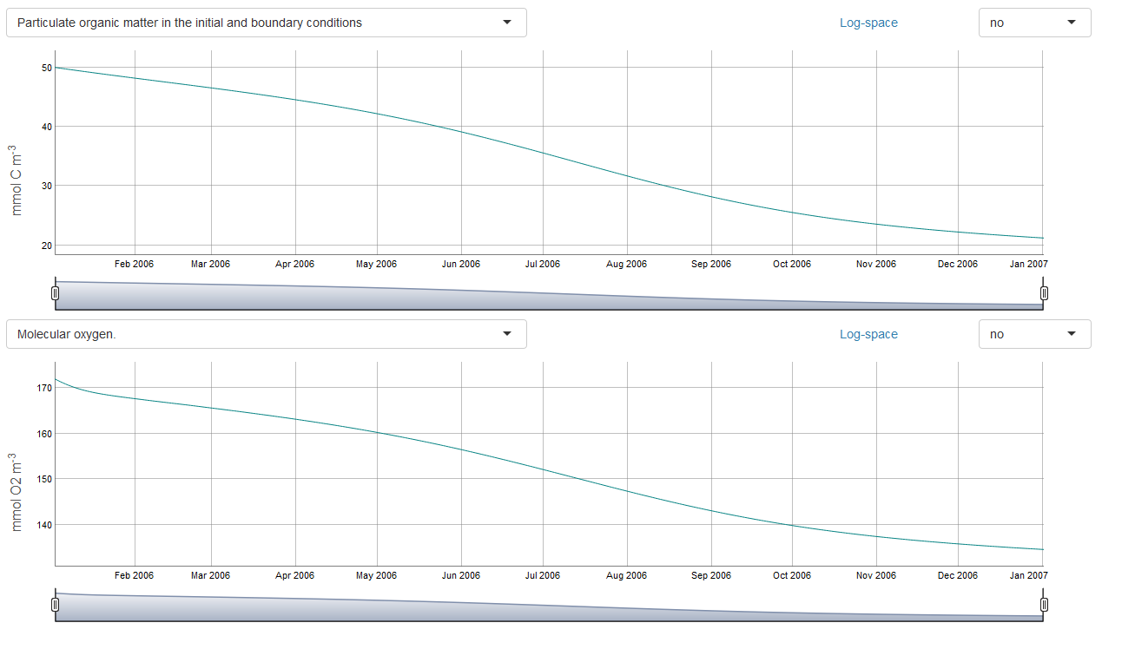

Make it decay faster by changing *KG1_BC*=30 in the **Organic Matter** section of the **Select parameters** tab.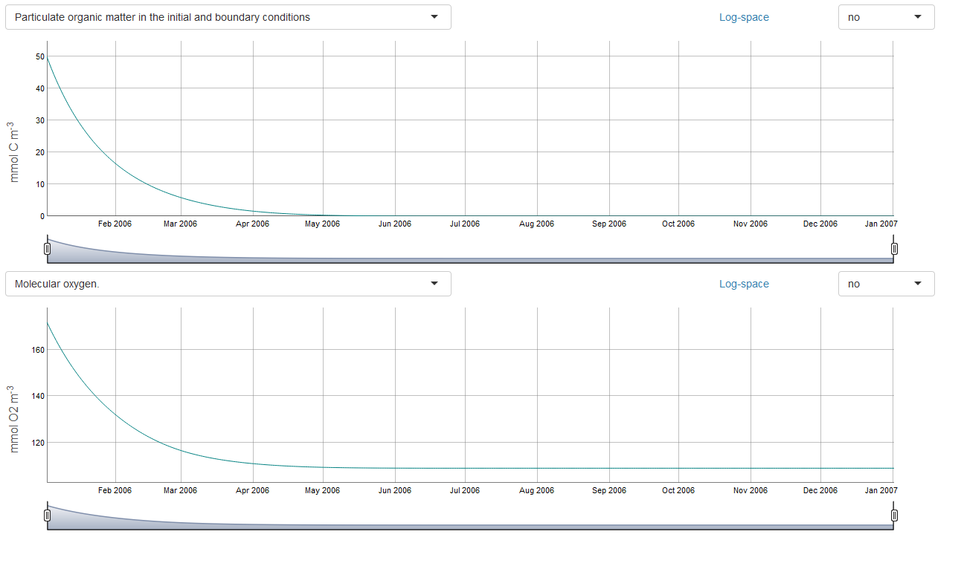

The organic matter parameters (nitrification, half saturation, etc.) can be calibrated or explored by keeping the plankton terms constant as shown and changing the OM parameter values and the initial values of O2, NO3, NH4, and PO4.